Image | 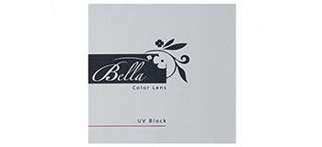
Brand | TIFFANY & CO.
Model Name | BELLA HEIGHLIGHT
Price | RS 3400
PRODUCT DETAILS

